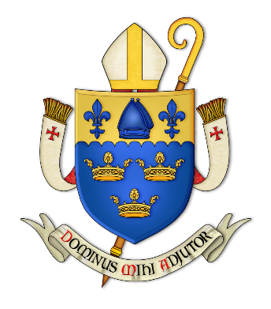
St Elizabeth’s Scarisbrick Served by the monks of Douai Abbey
Registered Charity No. 1063237
PRELIMINARY APPLICATION TO MARRY IN
ST. ELIZABETH’S CHURCH
Welcome to the parish of St Elizabeth’s. We look forward to welcoming you and helping to arrange your marriage. Please complete the information below and return to the parish office at St Elizabeth’s at least six months before the proposed date of your marriage. Please ensure the church is available before booking the venue for your wedding. One of our priests will then contact you to discuss things further. Please note if you do not live in the parish permission for you to be married at St Elizabeth’s will have to be obtained from your local Parish Priest

Proposed date & time of Marriage
Name of Bridegroom
Address

Telephone No: E-mail address:
Religion

Name of Bride
Address

Telephone No: E-mail address:
Religion

Please add any additional information regarding your proposed marriage on a separate sheet

